

**Internship project Report**

**on:**

# **“DEVELOPMENT OF AI TOOL FOR THE DETECTION**

# **OF MINES USING GPR ”**

# 

**Submitted by:**

Manjeet Meena (2018MED1006)

**Email id:** [**2018med1006@iitrpr.ac.in**](mailto:2018med1006@iitrpr.ac.in)**,**

*UNDER THE GUIDANCE OF*

**Dr.Manish Agrawal & Dr.Srikant Padhee**

**DEPARTMENT OF MECHANICAL ENGINEERING**

**IIT ROPAR**

**RUPNAGAR, PUNJAB - 140001**

**2021-2022**

*Submission Date:21 September,2021*

# **Introduction:**

**Motivation:**

Wars claim enough human lives, not only if parties square measure concerned in it, but also years once it's over. infinite numbers of mines square measure left wide round the war zone and cause as a threat to the civilian population around. Not solely civilians but a decent variety of our soldiers have lost their lives to those mines attempting to seek out and neutralize them. In line with the landmine monitor report 2018, a minimum of 2793 people were killed and 4431 were battle-scarred within the year 2017. Among these eighty seven were civilians and around forty seventh were youngsters. The most important numbers of casualties were in Asian countries (2,300), Syria (1,906), and Ukraine (429). Since these cannot be caught using metal detectors, these pose an even greater threat. This calls for a new technology to be developed that can be used to detect these mines.

**About GPR technology:**

In this project, we tend to be attempting to develop an associate AI based tool primarily based upon the GPR, with which we'll be able to not solely notice however localize that mine for a given region. The GPR technology uses magnetic force radiations to notice underground objects based upon the magnetic force responses from the surface. There are a great deal of things and parameters that require optimization.

**Algorithms:**

The idea revolves around implementing a convolution neural network (CNN) upon the info obtained by the GPR. The info needed for initial coaching and testing of the network, is obtained by running numerous simulations on the gprMax software package, in which we are able to style a subterranean per our wants and find the info that a GPR should have been given for that sort of state of affairs. information is generated for various types of terrains with and while not mines and is employed to coach the model.

**Autoencoders** is also a new and more efficient algorithm being used in the field of mine detection.The autoencoders are being trained on mine-free data and when the model encounters a mine signature, it sees it as an anomaly. With this technique however, there are chances that something that is not mine but was never encountered by the autoencoder before will also be treated as an anomaly, thus increasing the chances of false detection.

**Theory Behind GPR:**

Ground-penetrating radar (GPR) is a [geophysical](https://en.wikipedia.org/wiki/Geophysics) method that uses [radar](https://en.wikipedia.org/wiki/Radar) pulses to [image](https://en.wikipedia.org/wiki/Geophysical_imaging) the subsurface. It is a non-intrusive method of surveying the sub-surface to investigate underground utilities such as concrete, asphalt, metals, pipes, cables or masonry. This [nondestructive](https://en.wikipedia.org/wiki/Nondestructive_testing) method uses [electromagnetic radiation](https://en.wikipedia.org/wiki/Electromagnetic_radiation) in the [microwave](https://en.wikipedia.org/wiki/Microwave) [band](https://en.wikipedia.org/wiki/Band_(radio)) ([UHF](https://en.wikipedia.org/wiki/Ultra_high_frequency)/[VHF](https://en.wikipedia.org/wiki/VHF) frequencies) of the [radio spectrum](https://en.wikipedia.org/wiki/Radio_spectrum), and detects the reflected signals from subsurface structures. GPR can have applications in a variety of media, including rock, soil, ice, fresh water, pavements and structures. In the right conditions, practitioners can use GPR to detect subsurface objects, changes in material properties, and voids and cracks.

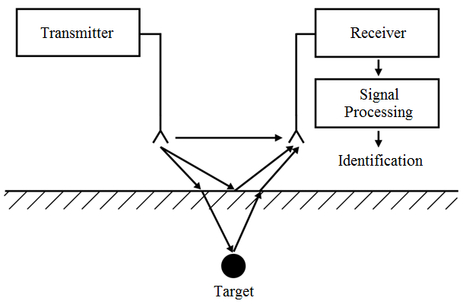

**Figure 1. Block diagram of GPR system**

**Basic Principle:**

The practical results of the radiation of magnetic force waves into the submarine for GPR measurements is shown by the fundamental operative principle that's illustrated in Figure 1. The electromagnetic radiation is radiated from a transmittal antenna, travels through the material at a speed that is set primarily by the permittivity of the fabric. The wave spreads out ANd travels downward till it hits an object that has totally different electrical properties from the encircling medium, is scattered from the item, and is detected by a receiving antenna.

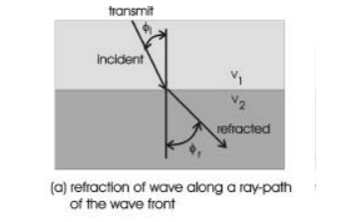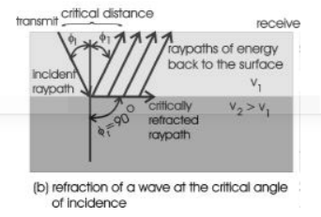

**Figure 2. Transmitted electromagnetic wavefront scattered from a buried object with a contrasting permittivity. Permittivity of the host media is ee1, and the permittivity of the buried object is ee2.**

Antennas may be thought of to be transducers that convert electrical currents on the aluminiferous antenna parts to transmit magnetic force waves that propagate into a cloth. Antennas radiate magnetic force energy once there's an amendment within the acceleration of the present on the antenna. The acceleration that causes radiation could also be either linear,(e.g., a time-varying electromagnetic radiation traveling on the antenna), or angular acceleration. Antennas additionally convert magnetic force waves to currents on AN antenna component, acting as a receiver of the nonparticulate radiation by capturing a part of the electromagnetic radiation. The principle of reciprocity says that the transmit and receive antennas ar interchangeable, and this theory is valid for antennas that ar transmittal and receiving signals within the

air, well higher than the surface of the bottom. Electromagnetic waves travel at a selected speed that's determined primarily by the permittivity of the fabric. The link between the speed of the wave and material properties is the basic basis for exploitation of GPR to analyze the submarine. To state this basic physical principle in an exceedingly {different|totally totally different|completely different} way: the speed is different between materials with totally different electrical properties, and a symbol felt 2 materials with {different|totally totally different|completely different} electrical properties over constant distance can make different times. The interval of time that it takes for the wave to travel from the transmit antenna to the receive antenna is solely known as the period of time. The fundamental unit of electromagnetic radiation travel time is the time unit (ns), wherever one ns = 10-9 s. Since the speed of AN electromagnetic radiation in air is 3x108 m/s (0.3 m/ns), then the period of time for AN magnetic force wave in air is around three.3333 ns per m traveled. Specular scattering is based on the Law of Reflection, where the angle of reflection is equal to the angle of incidence, or .

When a wave impinges on an interface, it scatters the energy per the form and roughness of the interface and therefore the distinction of electrical properties between the host material and therefore the object. a part of the energy is scattered into the host material, while the other portion of the energy might travel into the item. The portion of the wave that propagates into the item is alleged to be refracted. The angle that the wave enters into the item is determined by Snell’s law, which might be explicit as follows:

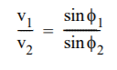

where v1 and v2 area unit the velocities of the wave through the higher and lower materials, respectively, and f1 and f2 area unit the angles of the ray path for the incident and refracted waves, severally.

In practice, GPR measurements can be made by towing the antennas continuously over the ground, or at discrete points along the surface. These two modes of operation are illustrated in Figure A5. The fixed-mode antenna arrangement consists of moving antennas independently to different points and making discrete measurements, while moving-mode keeps the transmit and receive antennas at a fixed distance with the antenna pair moved along the surface by pulling them by hand, or with a vehicle. The fixed-mode arrangement has the advantage of flexibility, moving-mode has the advantage of rapid data acquisition. In practice, a combination of fixed-mode and moving-mode provides an optimum mixture of flexibility and mobility. Measurements made in the fixed mode can be used to determine the best spacing and antenna orientation for making moving mode measurements. Some systems enable the operator to make both types of measurements with the same antennas and electronics.

* **Basics of gprMax (simulation software):**

gprMax is open source software that simulates electromagnetic wave propagation. It uses Yee's algorithm to solve Maxwell’s equations in 3D using the [Finite-Difference Time-Domain (FDTD)](https://en.wikipedia.org/wiki/Finite-difference_time-domain_method) method. The finite difference expressions for the spatial and temporal derivatives are central-difference in nature and second-order accurate.

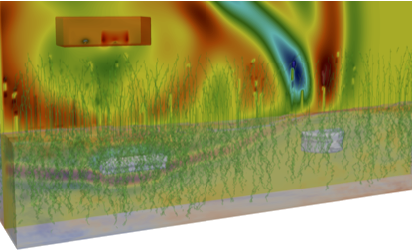

**Figure 4. GPR wave propagation in a landmine environment**

It is designed for simulating [Ground Penetrating Radar (GPR)](https://en.wikipedia.org/wiki/Ground-penetrating_radar) and can be used to model electromagnetic wave propagation in fields such as engineering, geophysics, archaeology, and medicine. There are a [wide range of applications](https://www.gprmax.com/publications.shtml) including: assessing critical infrastructure such as bridges and roads, locating buried utilities, mapping glaciers, finding anti-personnel landmines, and detecting tumours in the human body.

gprMax is command-line-driven software written in [Python](https://www.python.org/) with performance-critical parts written in [Cython](http://cython.org/). It currently does not feature a graphical user interface (GUI) which allows it to be very flexible and scriptable software that can run in high-performance computing (HPC) environments, i.e. on supercomputers.

# **Optimisation - Taguchi’s method**

It allows users to define parameters in an input file and optimise their values based on a fitness function, for example it can be used to optimise material properties or geometry in a simulation.

Taguchi’s method is based on the concept of the Orthogonal Array (OA) and has the following advantages:

* Simple to implement
* Effective in reduction of experiments
* Fast convergence speed
* Global optimum results
* **Analysis of the data in gprMax software:**

1. **Here are our CNN model summary:**

This CNN model we found most accurate after changing the parameters and we are using SGD classifier in this model.

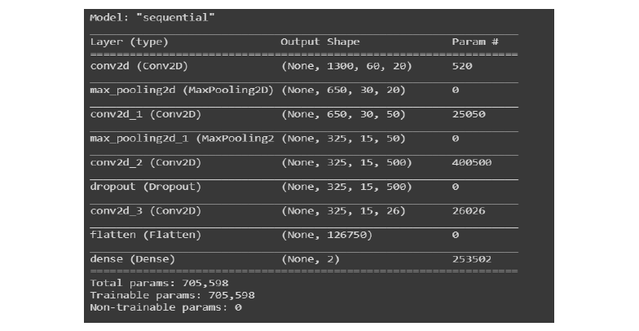

1. **First Input file:**

This file is made on Text editor by giving a set of properties of soil, grass and roughness etc

Here we have used 120 iterations.

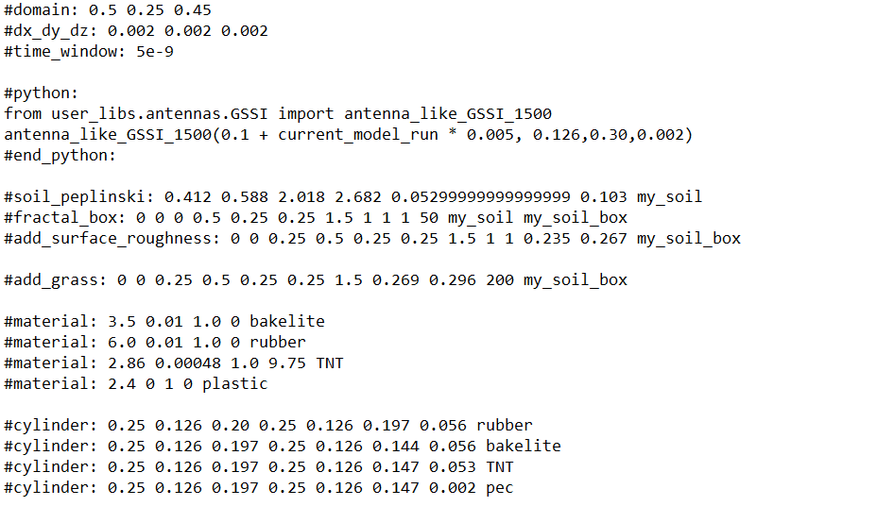

**Figure 1. Mine1 input data**

1. **Second input file:**

**No. of iterations are 60.**

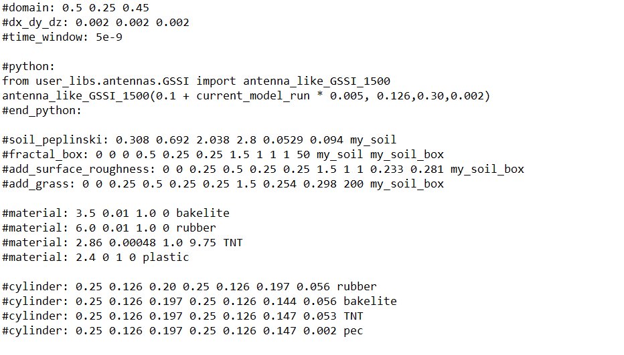

**Figure 2: data input file**

* **Simulation results from gprMax software:**

To study the effect of change in size of spatial discretization in gprMax, the simulated data generated using both 1 mm and 2 mm discretization size is observed. Although the results using the 1mm are more accurate, data generation using 1 mm discretization requires a great deal of computational power and an ample amount of time. In the 2 mm case, the results slightly deviate, but the advantage of less computational power outweighs the inaccuracy. 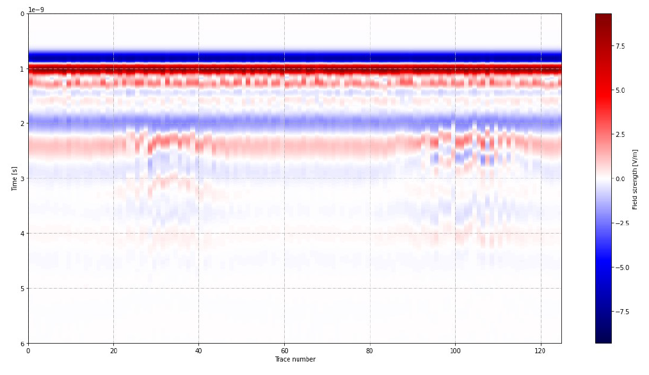

**Figure 3: B-scan (using Dx = 1 mm) for Mine1 file**

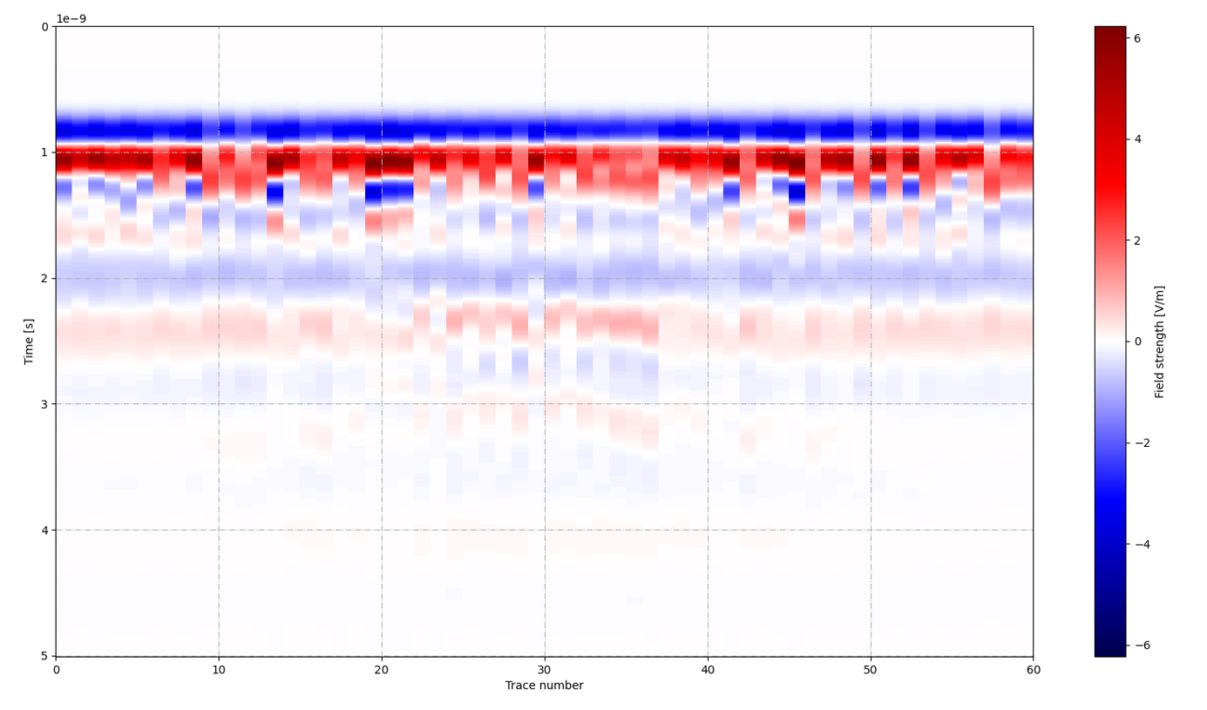

**Figure 4: B-scan ( using Dx = 1mm) for data file**

* **Observation and conclusion:**

In the ‘**Mine1 file**’ we can see more accurate results than the ‘**data file**’ because of no. of iterations we consider at the time of running these files. If we increase the no. of iteration we can get better hyperbola lines in the result. These hyperbola lines represent the pattern of field strength. Which helps in learning our model.

In this report, a completely unique technique for landmine detection exploitation gpr has been introduced. The planned system is ready to discover mines with the accuracy of ninety one.2% . Also the false negative is extremely low. the info used for coaching has been generated by exploitation gprMax package to copy reality conditions.The coaching data set used is extremely little (i.e., around four hundred B-scans) and therefore the convergence of the training is reached once a number of epochs (i.e., a number of minutes on a contemporary GPU). The proposed designs are often trained on any knowledge set so refined on the realm of investigation, whose conditions could vary everyday because of modification in climatic conditions and different external causes. Our model learns the patterns shaped by hyperbolas in B-scans.

**References:**

1. <http://docs.gprmax.com/en/latest/>
2. <https://towardsdatascience.com/simple-introduction-to-convolutional-neuralnetworks-> cdf8d3077bac
3. <https://www.sensoft.ca/blog/>
4. F Picetti, G. Testa, F. Lombardi, P. Bestagini, M. Lualdi and S. Tubaro, ”Convolutional Autoencoder for Landmine Detection on GPR Scans,” 2018 41st International Conference on Telecommunications and Signal Processing (TSP), Athens, 2018, pp. 1-4, doi: 10.1109/TSP.2018.8441206.